# Assignment 1

## Problem 1:

1. **Read AAUP data**

SAS Code:

DATA ACADEME;

INFILE 'C:\Users\mummidra\Dropbox\UC\FirstSem\Stat_Computing\Assignment_1\AAUP_data.txt' LRECL=32767 delimiter=',';

length FICE $4;

length College_Name $40;

INPUT FICE College_Name$ State_code$ Type$ Avg_Sal_Full_Prof Avg_Sal_Assoc_Prof Avg_Sal_Assistant_Prof Avg_Sal_All_Ranks Avg_Comp_Full_Prof Avg_Comp_Assoc_Prof Avg_Comp_Assis_Prof Avg_Comp_All_Ranks No_Full_Prof No_Assoc_Prof No_Assis_Professors No_Instructors No_Faculty_All_Ranks;

RUN;

PROC PRINT DATA=ACADEME;

RUN;

SAS Output: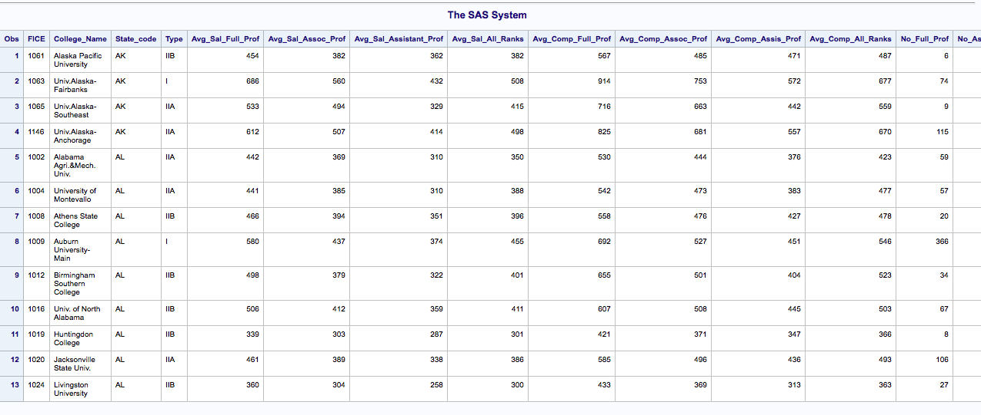

b) **Creating dataset with all average salaries and average compensations.**

SAS Code:

DATA ALLAVERAGES;

SET ACADEME;

DROP College_Name Type No_Full_Prof No_Assoc_Prof No_Assis_Professors No_Instructors No_Faculty_All_Ranks;

RUN;

PROC PRINT DATA=ALLAVERAGES;

RUN;

SAS Output:

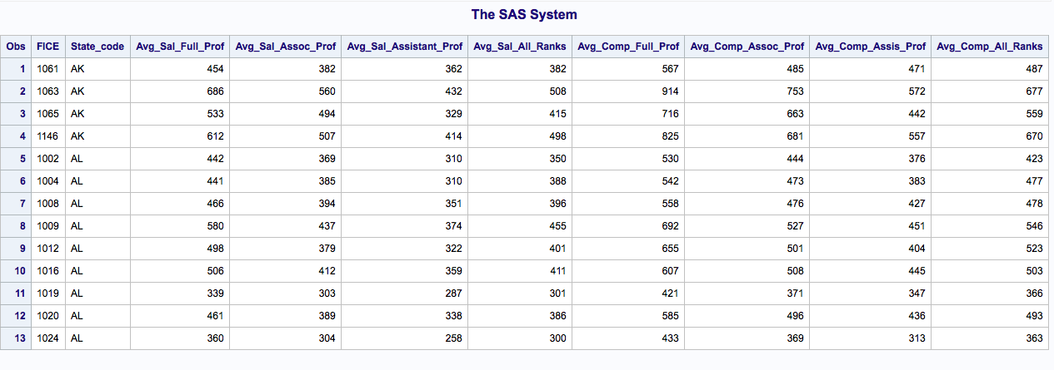

c) **create two subsets whose colleges are from AK or AL separately**

SAS Code:

DATA ALDDATASET;

SET ALLAVERAGES;

IF State_code='AL';

RUN;

DATA AKDDATASET;

SET ALLAVERAGES;

IF State_code='AK';

RUN;

PROC PRINT DATA=ALDDATASET;

PROC PRINT DATA=AKDDATASET;

RUN;

SAS Output:

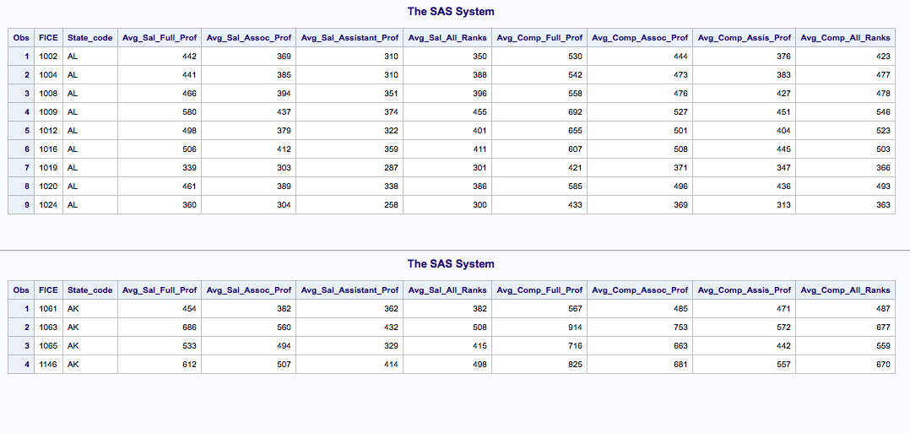

**d) total income dataset**

SAS Code:

DATA ALTOTALDATASET;

SET ALDDATASET;

TOT_Sal_Full_Prof=Avg_Sal_Full_Prof+Avg_Comp_Full_Prof;

TOT_Sal_Assoc_Prof=Avg_Sal_Assoc_Prof+Avg_Comp_Assoc_Prof;

TOT_Sal_Assis_Prof=Avg_Sal_Assistant_Prof+Avg_Comp_Assis_Prof;

TOT_Sal_All_Ranks=Avg_Sal_All_Ranks+Avg_Comp_All_Ranks;

DROP Avg_Sal_Full_Prof Avg_Sal_Assoc_Prof Avg_Sal_Assistant_Prof Avg_Sal_All_Ranks Avg_Comp_Full_Prof Avg_Comp_Assoc_Prof Avg_Comp_Assis_Prof Avg_Comp_All_Ranks;

RUN;

DATA AKTOTALDATASET;

SET AKDDATASET;

TOT_Sal_Full_Prof=Avg_Sal_Full_Prof+Avg_Comp_Full_Prof;

TOT_Sal_Assoc_Prof=Avg_Sal_Assoc_Prof+Avg_Comp_Assoc_Prof;

TOT_Sal_Assis_Prof=Avg_Sal_Assistant_Prof+Avg_Comp_Assis_Prof;

TOT_Sal_All_Ranks=Avg_Sal_All_Ranks+Avg_Comp_All_Ranks;

DROP Avg_Sal_Full_Prof Avg_Sal_Assoc_Prof Avg_Sal_Assistant_Prof Avg_Sal_All_Ranks Avg_Comp_Full_Prof Avg_Comp_Assoc_Prof Avg_Comp_Assis_Prof Avg_Comp_All_Ranks;

RUN;

PROC PRINT DATA=ALTOTALDATASET;

PROC PRINT DATA=AKTOTALDATASET;

RUN;

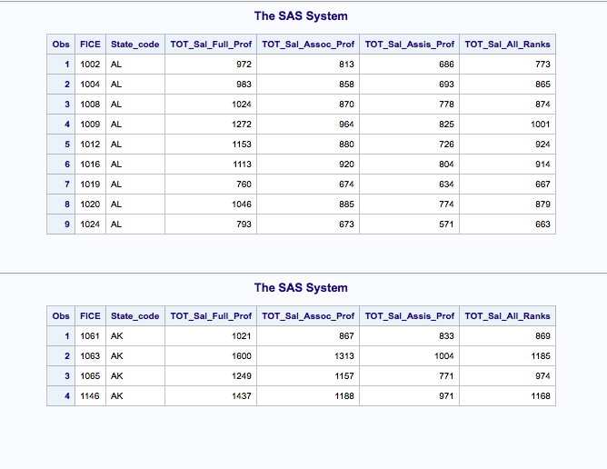

Problem 2:

1.Code after correction:

SAS Code:

DATA SCORE_LIST;

INPUT SCHOOL$ MATH_BEFORE MATH_AFTER@@;

MATH_IMPROVE= MATH_AFTER- MATH_BEFORE;

CARDS;

UC 80 81 UC 80 80 UC 90 87 OSU 70 80

OSU 78 80

;

RUN;

DATA LIST_NEW;

KEEP SCHOOL MATH_IMPROVE;

RUN;

PROC SORT DATA=LIST_NEW OUT=LIST2;

BY MATH_IMPROVE ;

DATA LIST2;

SET LIST2;

IF MATH_IMPROVE>0 THEN GOOD=’YES’;

ELSE GOOD=’NO’;

RUN;

PROC PRINT DATA=LIST2;

RUN;

2 Running corrected code in SAS

SAS Code:

DATA SCORE_LIST;

INPUT SCHOOL$ MATH_BEFORE MATH_AFTER@@;

MATH_IMPROVE=(MATH_AFTER-MATH_BEFORE);

CARDS;

UC 80 81 UC 80 80 UC 90 87 OSU 70 80

OSU 78 80

;

RUN;

DATA LIST1_NEW;

SET SCORE_LIST;

KEEP SCHOOL MATH_IMPROVE;

RUN;

PROC SORT DATA=LIST1_NEW OUT=LIST2;

BY MATH_IMPROVE;

DATA LIST2;

SET LIST2;

IF MATH_IMPROVE>0 THEN GOOD='YES';

ELSE GOOD='NO';

RUN;

PROC PRINT DATA=LIST2;

RUN;

SAS Output:

